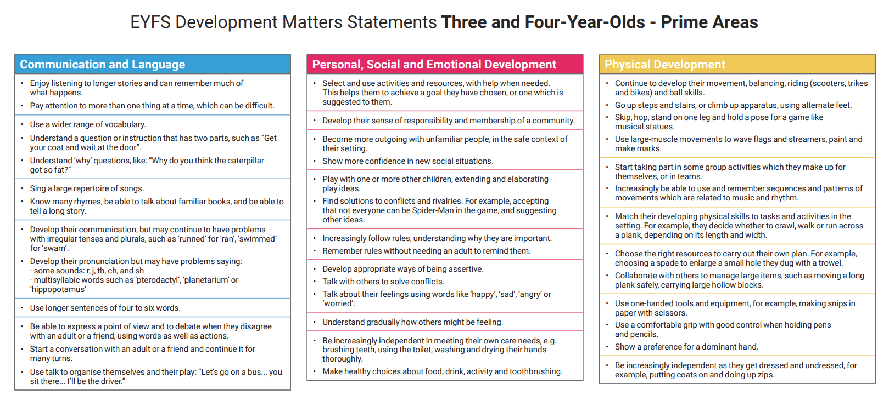

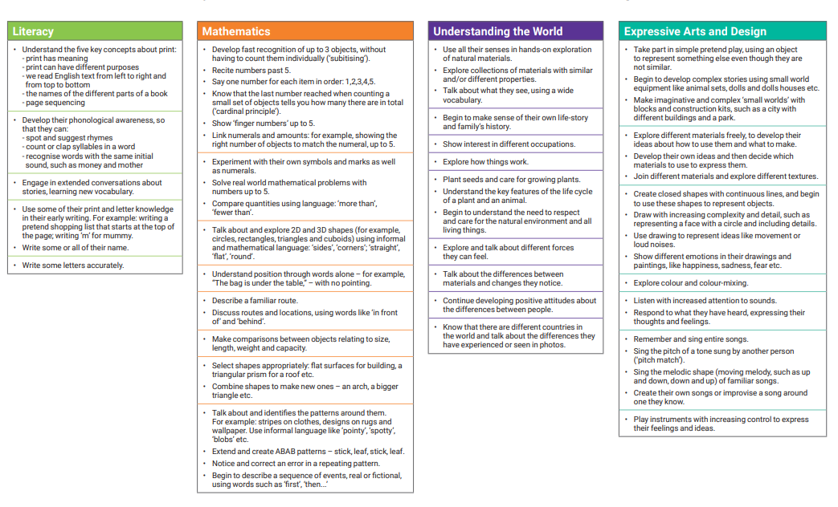
We will be facilitating the learning from Development Matters through the following topics:
Autumn 1 – Ourselves
Autumn 2 – Celebrations
Spring 1 – Winter and keeping healthy
Spring 2 – Minibeasts
Summer 1 – Growing and animals
Summer 2 – People who help us/transitions

